

***Hands-On Exercise 7.3 [20-points]: Displaying all the nodes in a binary tree (:10 min)***

### *Instructions:*

* According to some research, industry values documentation, and excellent written and oral communication skills. The purpose of this part of the class is to encourage you to gain these skills.
* Backup your work to your USB drive for this material may come out as part of your examination.
* Make a copy of this entire document and add your work into it.
* Submit to Blackboard at the same link where you got this document.
* Points will be a deducted if submitted on the wrong place, or if these instructions are not followed.

1.❑ Add the inorder() method to the IntBST class you have created before:

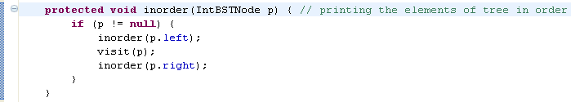

2.❑ Test the inorder() method you’ve just added:

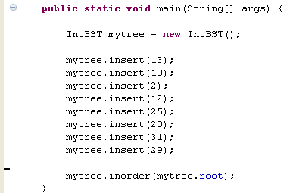

3.❑ Paste your code here.

**protected** **void** inorder(IntBSTNode p){

**if**(p != **null**){

inorder(p.left);

visit(p);

inorder(p.right);

}

}

**package** Excercise7_1;

**public** **class** Driver {

**public** **static** **void** main(String[] args) {

// **TODO** Auto-generated method stub

IntBST mytree = **new** IntBST();

mytree.insert(13);

mytree.insert(10);

mytree.insert(2);

mytree.insert(12);

mytree.insert(25);

mytree.insert(20);

mytree.insert(31);

mytree.insert(29);

mytree.breadthFirst();

System.***out***.println();

mytree.inorder(mytree.root);

}

}

4.❑ Paste your screen shot output here [Ctrl] + [PrtScn]. Make sure you magnified it.

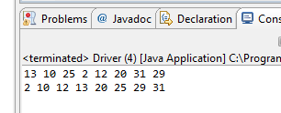

5.❑ Write your topmost question regarding this topic.

Are there instances to not use binary trees? They seem so much more simple, especially for sorting.

6.❑ **Critical Thinking:** If you are asked to make a test question based on this topic, what would be the question and what is your answer?

In the above code what algorithm is being used for sorting?

Answer: Recursion

[](http://images.google.com/imgres?imgurl=www.skyscript.co.uk/im/trophy.jpg&imgrefurl=http://www.skyscript.co.uk/im/&h=214&w=180&sz=6&tbnid=ECCiP8U-7NsJ:&tbnh=99&tbnw=84&prev=/images?q=trophy&svnum=10&hl=en&lr=&ie=UTF-8&oe=UTF-8&sa=G)Congratulations! You’ve just learned how to display all the nodes in a binary tree.

**Submission Procedure**

1. Write your **name** here: ___Joshua LeGoff__________________
2. Date: __11/10/2015____________________
3. **Backup** your work to your USB drive, this material may come out as part of your exam.
4. **Submit** to Blackboard at the link where you got it.

**Note:**

* Submit back to Blackboard where you get it.
* 2-points deduction if you submit it on the wrong place.
* 2-points deduction if you did not follow these instructions.
* Make sure you submit it at the correct location where you got it.

|  |  |  |  |  |
| --- | --- | --- | --- | --- |
| GRADING RUBRIC | | | | |
| Grading Criteria | 3  **Exceeds**  *Excellent*  Epic Wow | 2  **Meets**  *Satisfactory*  O.K. | 1  **Partially Meets**  *Below Expectations*  Not Yet | 0  **Does Not Meet**  *Unacceptable*  Fail |
| **Completeness** | +5-Completed all the required work and added more examples. | +2-Completed all the work required. | +1-Partially completed the work required. | Unfortunately, did not complete the work required. |
| **Coding** | +10- Code is excellent, comments are added, and different techniques were used. | +7-Code is O.K., and program works. | +4-Code works, but still needs improvement. | Unfortunately, no coding. |
| **Output** | +5-Outputs are correct, and provided additional output cases. | +2-Output meets requirement and is readable. | +1-There is output, but not readable, and/or needs improvement. | Unfortunately, no output. |
| **Late** | Excellent, you submitted it before the deadline. | -5, unfortunately for submitting after the deadline. | -7, unfortunately for submitting several weeks after the deadline. | -10, unfortunately, for submitting very late. |